

Mobile voting application

In depth Solution Analysis for a Voting Mobile Application



December 3, 2017

Let's Vote!

DEVELOPED BY: DANIEL BELANGER, EUNBIN PARK, HAMZA ZAFAR, STEVEN FRANCESHI, YONGJI HUANG



Table of Contents

Term Project Review 3

Summarizations of Analysis Requirement Activities 3

Summarizations of Design Activities 3

Problem Background Research 4

Executive Summary 7

Problem Focus 7

Problem Solution 7

Design Cost 8

Solution Implementation Timeline 9

Requirements Specification (Analysis) 10

Itemized Requirements (Functional & Non-functional) 10

Context Data Flow Diagram 11

Level 1 Diagram: Manage Event 11

Level 2 Diagram: Manage Message 12

Use Case Diagram 13

Use Case Descriptions 14

Activity Diagrams 17

Sign-In Activity Diagram 17

Message Sending Activity Diagram 18

Event Creation Activity Diagram 19

Sequence Sign-In Diagram 19

Conceptual Data Model 20

Detailed Design Specification 21

Logical Data Model 21

User Interface Design 22

Preface 22

Windows Navigation Diagrams 22

Class Model 36

Physical Architecture Diagram 37

Appendix A 38

System Request Document 38

Initial Project Scope 38

Schedule for Project 39

Gantt Chart: 39

Feasibility 40

Appendix B 41

References 41

# Term Project Review

## Summarizations of Analysis Requirement Activities

## Summarizations of Design Activities

# Problem Background Research

For our project we decided to find a way to link government to new media technologies, in our case a mobile application. The voter turnout and political engagement among the young adult demographic (18-24), known commonly in the media as “millennials”, have been trending downwards in western nations, i.e. the USA and the EU (Esser and de Vreese, 2007). According to Elections Canada turnout data Canada has not been immune to this effect and has seen a similar trend among its voters. While there are many reasons that this is happening, the specifics vary from country to country and so we will be focusing on those which affect Canadians the most. Young adult voters in Canada are interested in politics, with only 29% of them thinking that politics is boring, and 78% of them believe that their vote matters (Dougherty, 2011). So why is it then that young Canadians aren’t voting? The primary reason given is that they simply feel that they don’t have enough information to vote. This feeling is not unique to the younger demographic and is in fact a problem faced by all Canadian voters (Blais et al, 2008). A great example of the need to be informed is the confusion caused by the differences between provincial and federal parties of the same names (Pruysers, 2013). The only party in Canada to have direct integration between provincial and federal levels is the NDP. For example, the Liberal party of British Columbia has no ties to the Federal party of the same name, and in fact the name is the only similarity and the federal party it is most aligned with are the Progressive Conservatives. Clearly there is a need for a better way of creating informed voters. The second reason young voters give for not voting is that they simply aren’t asked to. They require a greater feeling of participation that simply isn’t being given to them by the recent political campaigns. This problem manages to compound itself as less young people are voting because they don’t feel engaged by their politicians, and less politicians are attempting to engage with young voters because they aren’t voting. Looking at all of this information we have decided that the problem we would like to focus on for our project is low voter turnout in the 18-24 demographic and increasing the number of informed voters overall.

The way we decided to tackle these two problems is by creating an app that would allow the user to find out information relevant to voting based on their location. This includes being able to see who your representatives are at the municipal, provincial, and federal levels, and then being able to see their policies as well of the policies of their affiliated party. This will hopefully allow voters to become more informed while requiring minimal effort, thus making it more accessible to a wider range of people. Our application would also allow the user to see important upcoming events, such as elections or town hall meetings, so that the user can feel more connected to politics. It is our hope that these two features alone will have a significant impact in the young voter demographic as they help to address their primary concerns and it also comes in the form of a mobile application, which is the most popular among the young adult demographic (Dogtiev, 2017). The use of media to engage young people in politics has been shown to be effective and hopefully this app will facilitate an even greater level of engagement (Pasek et al, 2006).

Similar initiatives have been undertaken in other countries, the premier example of which being the use of technology by government in Estonia, known as e-Estonia (Kalvet, 2012). While several countries have conducted internet voting trials Estonia has advanced the farthest in deployment and has had great success with implementing e-government, expanding it to include features such as i-Voting, e-Tax Board, e-School, etc. This precedent shows us that the use of information technologies by governments can be hugely beneficial and can be a very useful tool in political outreach and involvement. However, Estonia is a small country, both population wise and geographically, compared to Canada and so while we may take inspiration from their initiatives there will likely be specific needs and difficulties that come with developing similar technologies for Canada.

The most important organization in our problem domain is unequivocally, and perhaps obviously, the Government of Canada. Though the municipal, provincial, and federal governments are administered separately for the sake of conciseness they will all together be referred to as the Government of Canada in this document, even though that technically only refers to the federal level. While the government is clearly involved in our problem domain it does not actually influence our solution as all the information necessary to create our application is in the public domain. This is extremely important towards the planning and implementation phases of our project as it ensures that we have free and easy access to all the information required to populate our database as well as reducing the need for legal costs in the launching of this application. Even though the government has no direct influence on our solution at this point, beyond being a source of data, the future of the app and its effects on voters could be greatly improved by greater government involvement. The app could act as a new form of outreach, specifically to the 18-24 mobile app loving demographic, if used personally by the politicians and their campaigns, for example taking polls on proposed legislation or making announcements of where they will be speaking. Though we have limited ourselves to developing this app for Canadians it would be a simple task to adapt this for other countries in the future at which point these other governments would become important to our problem domain.

It is our hope that even the most basic version of this app would work to address the problems of low young adult voter turnout as well as help to inform voters of all ages. As seen in other countries the reach of this app doesn’t need to stop at simply presenting information, and could hopefully one day be an integral part of how the government interacts with its voters.

# Executive Summary

## Problem Focus

In a world where the socio-political environment is heavily influenced by the citizens of the nation, todays generation does not take advantage of their right to vote and be heard. We want to help increase voter participation across Canada by developing a user friendly mobile application that consists of relevant information regarding the political situation within local, provincial, and federal branches.   
Our mobile application has the potential to expand across the globe and put more power in the hands of the people by increased participation in their respective countries elections.

## Problem Solution

Our solution is to provide Canadians with easily accessible information right at the tip of their fingers. The mobile application will be able to locate the users' location via GPS, and return information regarding relevant political representatives in the area, as well as past, current, and future elections. Furthermore, the application is open to all users, including members of parliament and local representatives, who can customize their public profile to make any changes to their platform. MPs can also respond to user's questions and address any concerns, which can improve ease of communication drastically between political leaders and their supporters.

This solution was designed in response to the current voter participation across Canada, specifically the age demographics of young adults who have a voter turnout percentage of 58%[1] Although this percentage has increased by 18.3% since 2011, we want our mobile application to help increase the percentage of ballots submitted by young Canadian adults even more. Furthermore, this project is highly feasible because it has potential to be approved by the government itself, thus increasing the likeliness of receiving funding for the venture.

## Design Cost

A very early estimate would predict that the total design cost for this project would range around $100,000[2] with a price ceiling that can go as high as up to $175,000[3] in the case of future expansion across multiple countries. (40 hours a week * 4.3454 weeks/month = ~ 173 hour per month)

1. **Collect data from organizations** (Library and Archives Canada, Elections Canada Online, the Open North database, as well as the official webpages of the representatives and official party websites)
   1. (Data miner, $35/ per hour[4]) * .5 month * 173 working hours/month)

= $3,270 * 5 Data Miners = **~$15, 150**

1. **Build database**
   1. (Business analysts, $40/ per hour[5]) * (1 month * 173 working hours/month)

= $6,920 * 3 Business analysts = **~$20,800**

1. **Design/Program mobile application (MAD)**
   1. (MAD, $25/ per hour[6]) * (3 months * 173 working hours/month)
   2. = $21,625* 2 Mobile Application Developers = **$43,250**
2. **Integrate database with mobile application**
   1. (Business analysts, $40/ per hour[7]) * (.5 month *173 working hours)

= $3,460 * 3 Business analysts = **~ $10,380**

1. **Ongoing maintenance & Management/Project oversight**
   1. (Information systems manager $50/ per hour[8]) * (5 months* 173 working hours)

= $43,250 * 1 Information Systems Manager = **~$43,250**

Total Labour Cost Approximately = $133,000

Database Server Cost = Difficult to approximate (assume under $2,000)

Mobile Application Store Cost = $50-$100[9]

**Total cost to develop Mobile Application = $135,000**

## Solution Implementation Timeline

This estimation is based on several key steps that lead up to the final delivery of the application. These include:

1. Data collection
   1. The initial step is to collect all relevant data from the right sources. This would require hiring data miners and business analysts to find, extract and record data from the various sources such as the government, members of parliament, current and future candidates, and other relevant political sources.
   2. Estimated time: 3 weeks
2. Build Database
   1. We must then create a database to store all the data and organize relationships and entities in the most efficient manner possible.
   2. Estimated time: 2 months
3. Program/Design Mobile Application
   1. Simultaneously, mobile application developers will be programming our mobile application to create a simple, user friendly UI.
   2. Estimated time: 3 months
4. Integrate database with the mobile application
   1. Finally, the database must work flawlessly through the mobile application which would require many tests and user reports.
   2. Estimated time: 3 weeks
5. Maintenance and user support
   1. Following the official launch of the application, we will provide user support for any questions or concerns.
   2. Estimated time: Ongoing

**Total time to construct Mobile Application: ~5 months**

# Requirements Specification (Analysis)

## Itemized Requirements (Functional & Non-functional)

Functional Requirements:

1. The app allows user to have a unique user ID and password to login,
2. The app allows user to use the menu side-bar to access different functional pages
3. The app allows user to change the app setting by clicking the “setting” button on Menu side-bar
4. The app allows user to upload their image as a personal picture
5. User’s password is encrypted when entered
6. User can change the app language between English and French
7. The app allows user to view events as a Calendar format
8. The app allows user to either add or delete an event in the Calendar.
9. The app allows user to view the event detail on Calendar page.
10. The app allows user to join a special event on the event detail page.

Non-Functional Requirements:

1. All jump between pages cast less than 0.01 seconds.
2. All request cost less than 3 clicks for users.
3. User’s login and password data are stored safe and encrypted.

## Context Data Flow Diagram

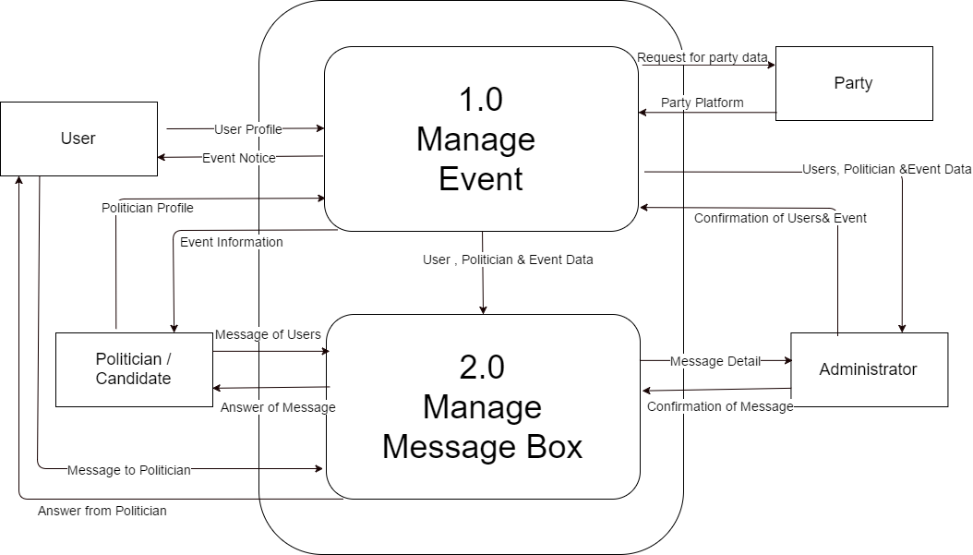

### Level 1 Diagram: Manage Event

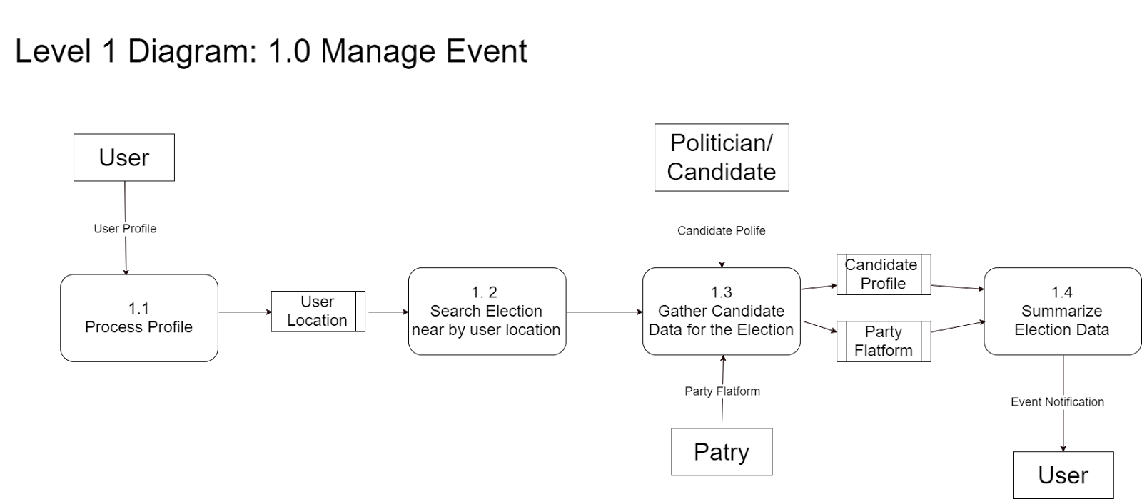

### Level 2 Diagram: Manage Message

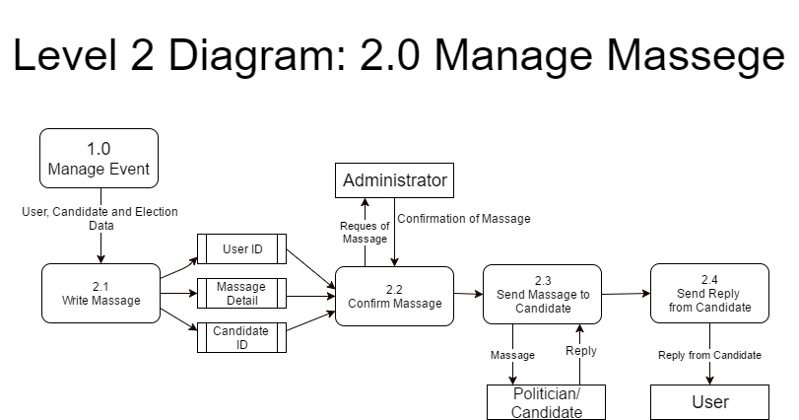

## Use Case Diagram

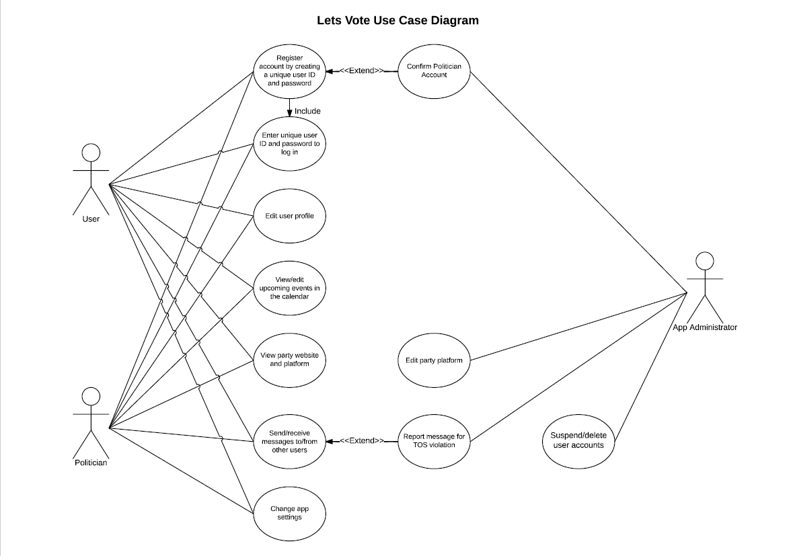

### Use Case Descriptions

|  |  |
| --- | --- |
| **Use Case ID** | 01 |
| **System** | Let's Vote App |
| **Use Case Name** | Creating a New User Account |
| **Actors** | User, Politician, App Administrator |
| **Brief Description** | This case describes how an order moves through the order fulfillment subsystem. |
| **Related Use Cases** |  |
| **Stakeholders** | User – Wants to register an account to use the app.  Politician – Wants to register an account to communicate with constituents.  App Administrator – Wants to confirm accounts so politicians can start using the app. |
| **Use Case Trigger** | User presses the “Sign Up” button. |
| **Normal Flow of Events** | 1. The user/politician presses the “Sign Up” button.  2. The user/politician provides their desired unique username.  3. The user/politician provides their desired unique password, and confirms it in a second password field.  4. The user politician chooses their account type; Standard or Politician.  5. The user/politician hits “Submit” to create their account.  If the user/politician selects a Standard account type, the account is created.  If the user/politician selects a Politician account type, they will need to link a verified Twitter or Facebook account to prove their identity.  6. The app administrator verifies politician accounts by looking at the linked Twitter or Facebook accounts and confirming them.  7. The user/politician account is now created, and the account can be accessed by logging in on the home screen. |
| **Alternate / Exceptional Flows** | 2a. The username is already in use by another account, the user/politician will be told to choose a new username.  3a. The two password fields don’t match up, the user/politician is directed to ensure that both fields are the same.  6a. The Twitter or Facebook account linked is not verified to be the politician, the account is rejected and deleted. |
| **Use Case ID** | 01 |
| **System** | Let's Vote App |
| **Use Case Name** | Sending/Receiving Messages |
| **Actors** | User, Politician, App Administrator |
| **Brief Description** | This case describes how messages are sent between users. |
| **Related Use Cases** |  |
| **Stakeholders** | User – Wants to communicate with a user or politician.  Politician – Wants to receive feedback or questions from constituents.  App Administrator – Wants to ensure that messages sent do not violate the Terms of Service. |
| **Use Case Trigger** | User presses the “Send Message” button on the page of another user. |
| **Normal Flow of Events** | 1. The sending user navigates to the page of the user/politician they want to send a message to.  2. The sending user hits the “Send Message” button.  3. The sending user types out the message they want to send and hits “Submit”.  4. The receiving receives the message in their inbox.  The user can hit the “Reply” button to send a response.  The user can hit the “Delete” button to delete the message.  The user can hit the “Report” button to block the sending user and send the message to an app administrator who will review it and take action if necessary.  5. If the message is reported, an app administrator will review it.  If the message violates the terms of service, the app administrator can suspend the sending user’s account or delete it permanently.  If the message does not violate the terms of service, the app administrator will take no action. |
| **Alternate / Exceptional Flows** | 2a. If the receiving user blocks the sending user, a “Send Message” button will not appear. |

## Activity Diagrams

### Sign-In Activity Diagram

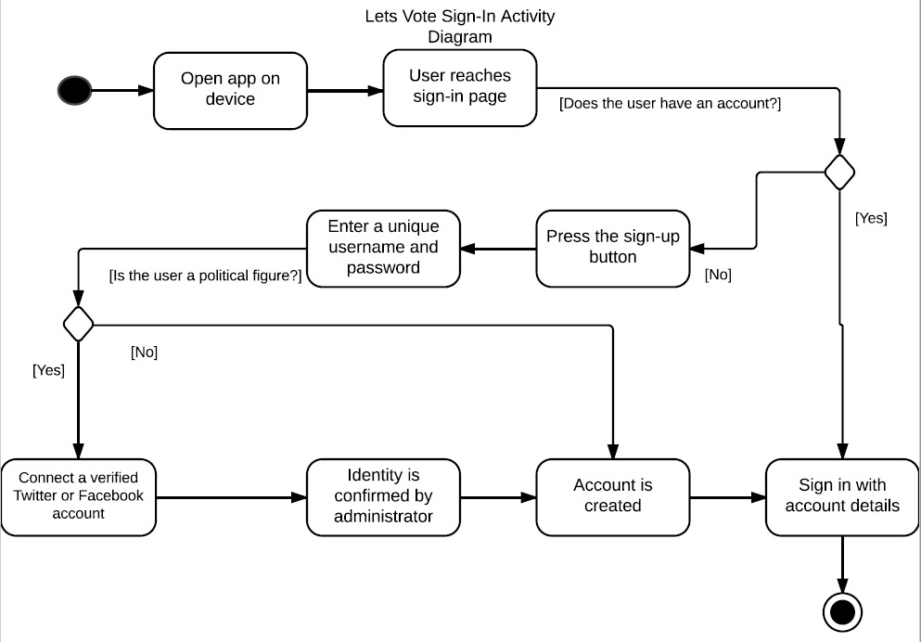

### Message Sending Activity Diagram

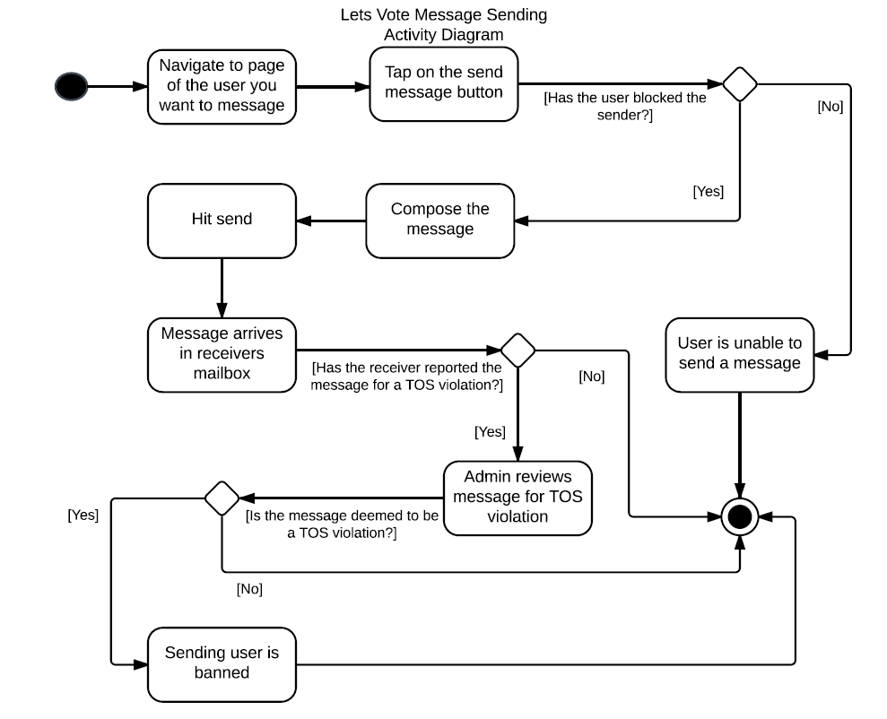

Event Creation Activity Diagram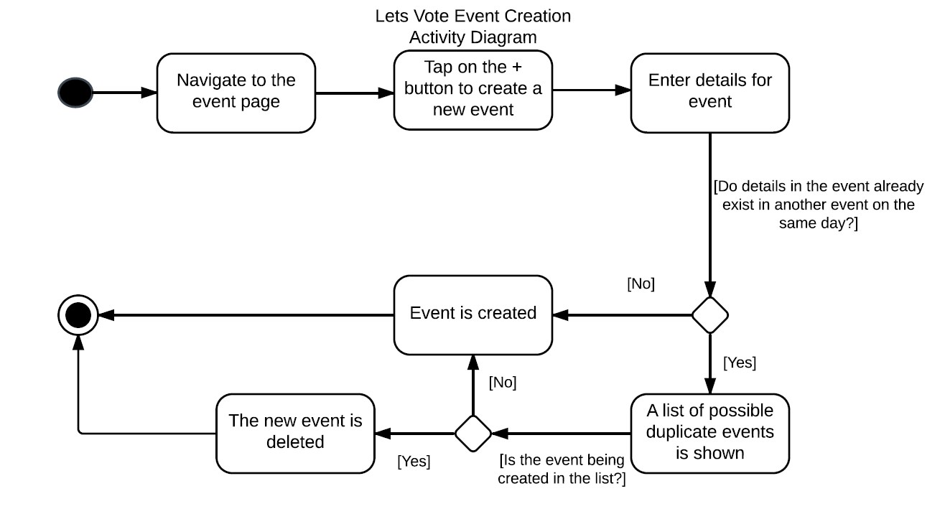

### Sequence Sign-In Diagram

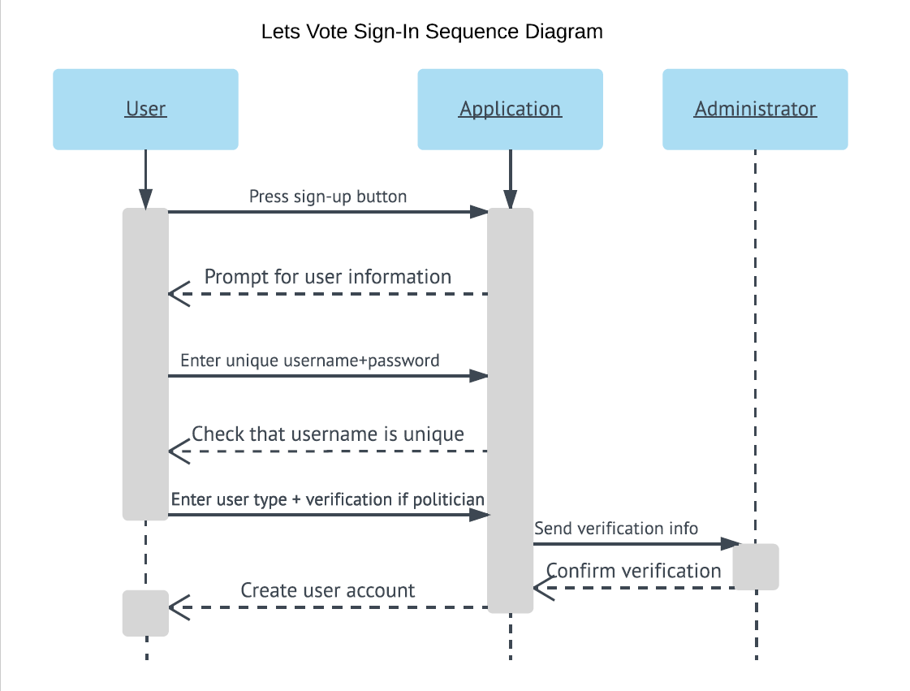

### Conceptual Data Model

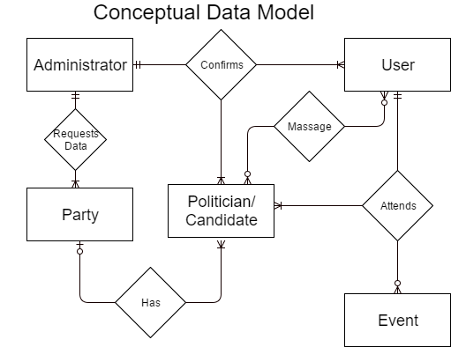

# Detailed Design Specification

## Logical Data Model

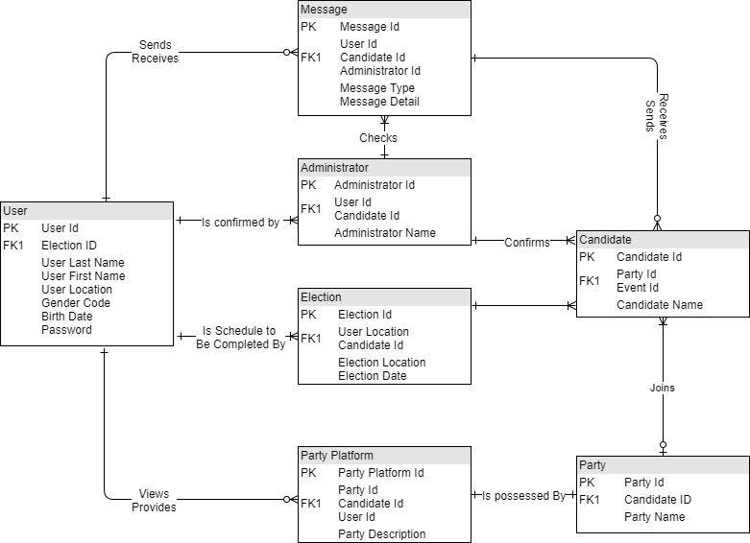

## User Interface Design

### Preface

The User interface mockup is screenshotted from a running application developed by Yongjia Huang using Java and Android Studio platform. Keep in mind that this is only for demo and presentation purposes and is NOT the final release version of the product. You may find the source code in Yongjia’s GitHub website referenced in Appendix B. The current version in this document is version 2. For more information about the demo app and the source code please contact Yongjia Huang at yongjia@ualberta.ca.

Notice the following demo is run on android but the final product will be available for iOS as well. Due to the differences in functionality between android and Apple hardware/software, the user interface may be slightly different on each device. For example, the iPhone 8 has a home button and a symmetrical screen ratio whilst the iPhone X interface has neither. Android on the other hand has a pre-installed back button on the screen, thus this functional requirement will not be present.

All pictures and texts included in the Mockup are selected from the links in Appendix B.

## Windows Navigation Diagrams

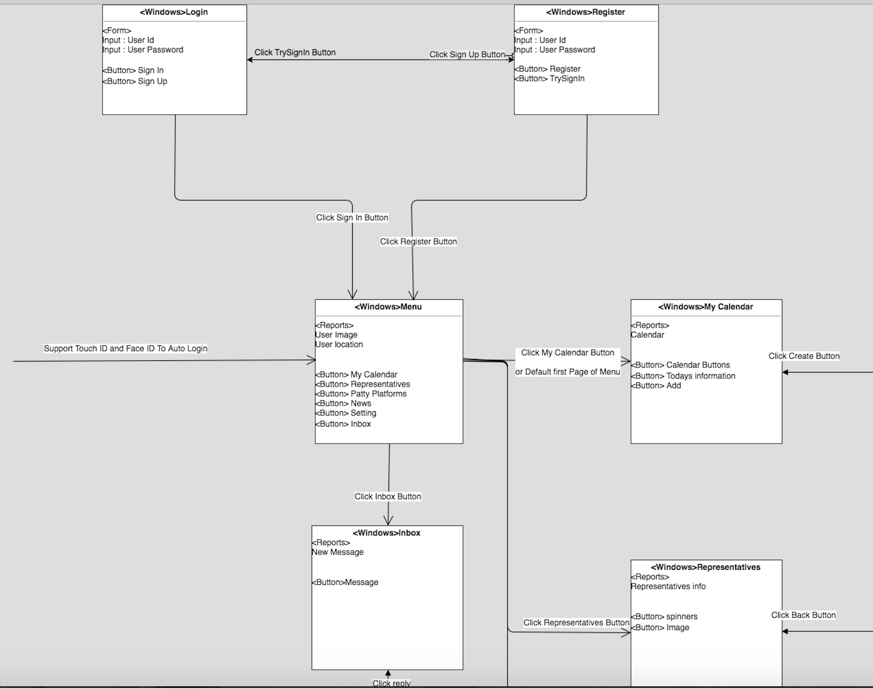

Figure 1: Login page and page after login

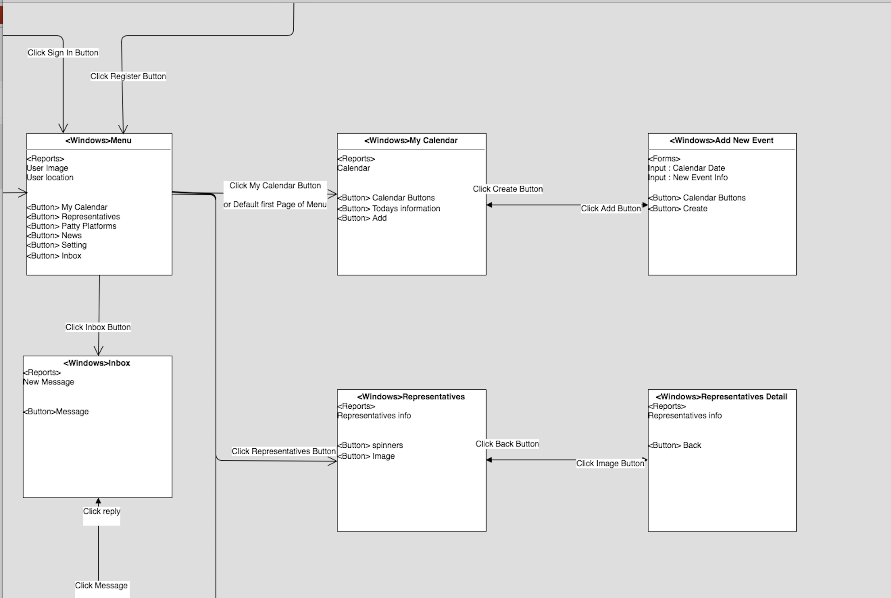

Figure 2: Main menu and linked pages

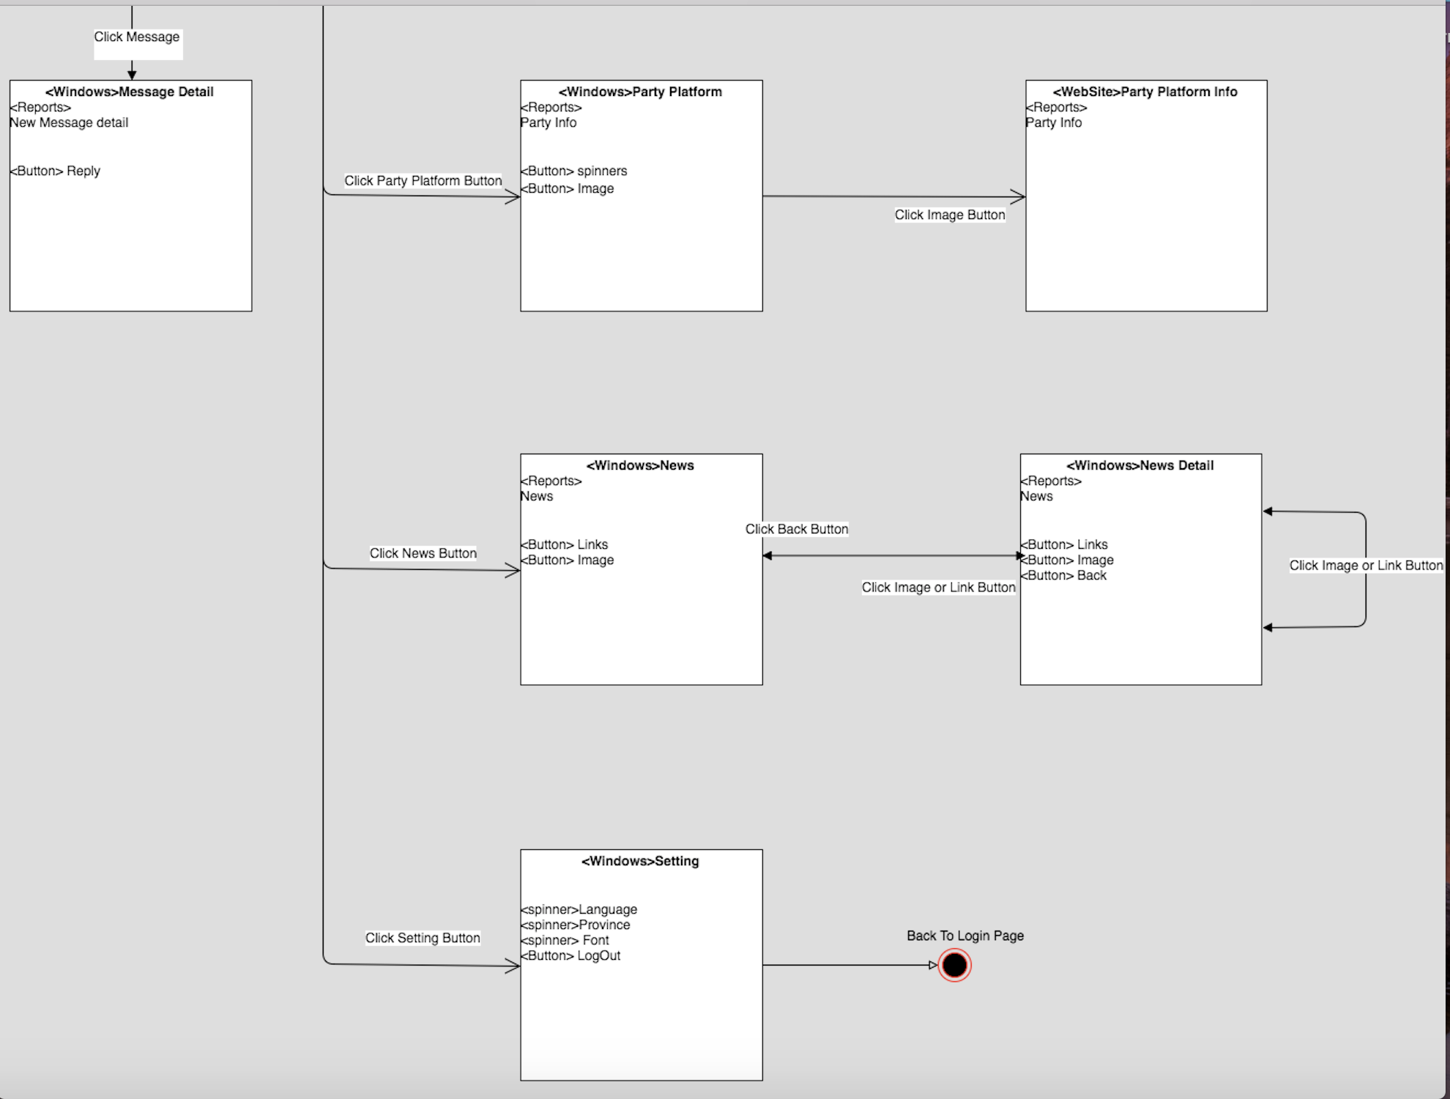

Figure 3: Linked page 1

For Completed Diagram, please check the enclosed file for: **“Windows Navigation Diagrams.png”**

**Interface and dialogue mockups and Specific processing rules :**

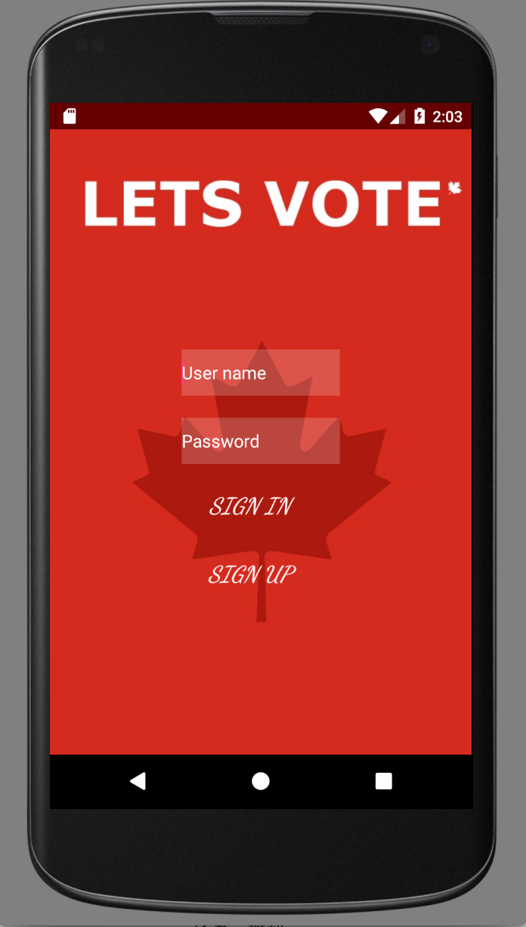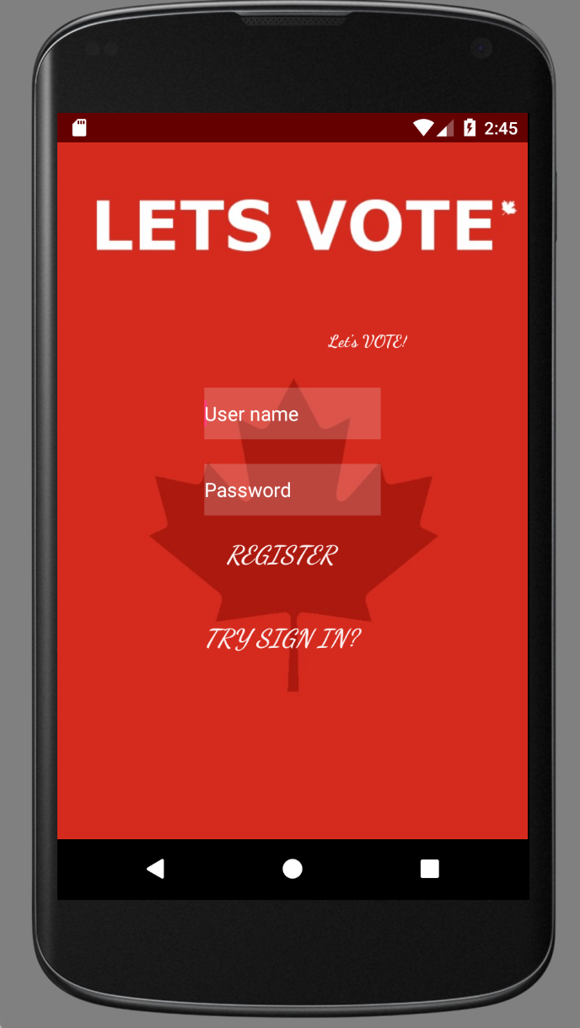

Figure 4.1, 4.2

Figure 4.1 is the first page when user launch the product, User can either choose login or do the registration ( click SIGN UP button and will leads you to the Figure 4.2 register page).

Since this app should be government issued (or get permission from the local government ), the user-name can be considered as SIN (social insurance number). When user enters the password, the password shown on the screen should be encrypted ( * instead), all data are stored safe and encrypted by using SQL as a database tool, the SQL database are stored on steam, for more information, jump to Physical architecture diagram for more detail.

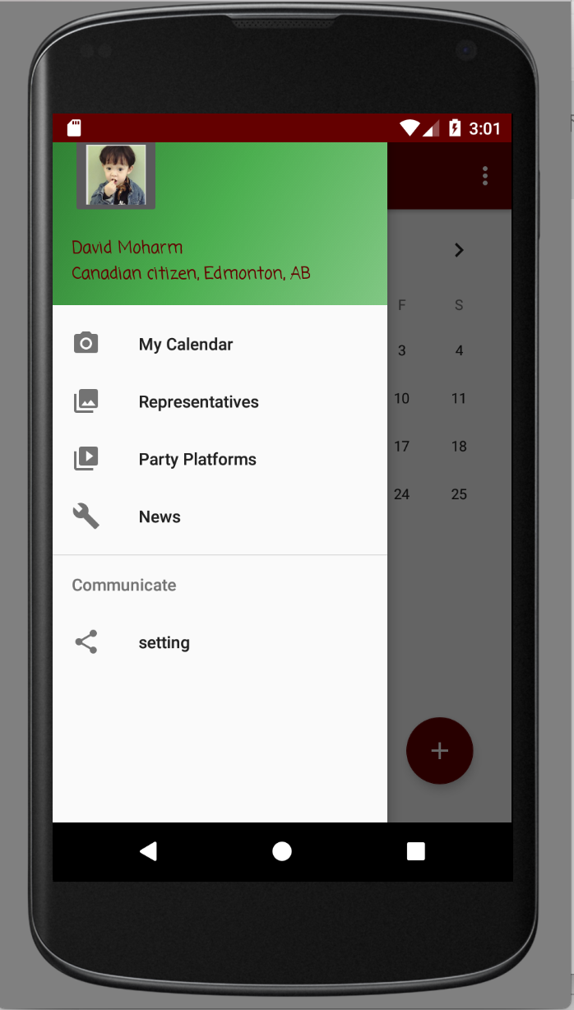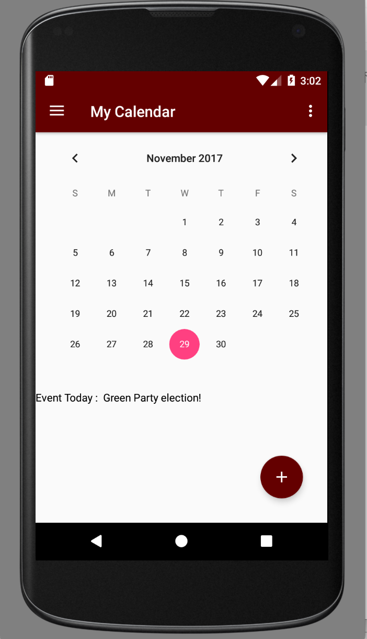

Figure 5.1, 5.2

Figure 5 is the first page after User click Sign In with valid username and Password, the Figure 5.1 is the Menu page that the product is actually jump in, but this is hidden from the Menu Button. The default (first page) view of the Menu is My Calendar (Figure 5.2)

The Menu (Figure 5.1) displays a user picture, user name and a location, the user picture is clickable and allows user to upload their own picture as a part of their profile, the location is automatically generated by the Google Map API V2 tool, user may disable it by closing the GPS in their phone. The Menu has five buttons which can lead users to different pages, and all those five pages can access the Menu page by clicking the menu button on top left corner.

The My Calendar Page (Figure 5.2) displays a calendar which allows user to view the post and upcoming event by clicking the date and click the text shown in the middle, User may also be able to add an event by click the “Plus” button.

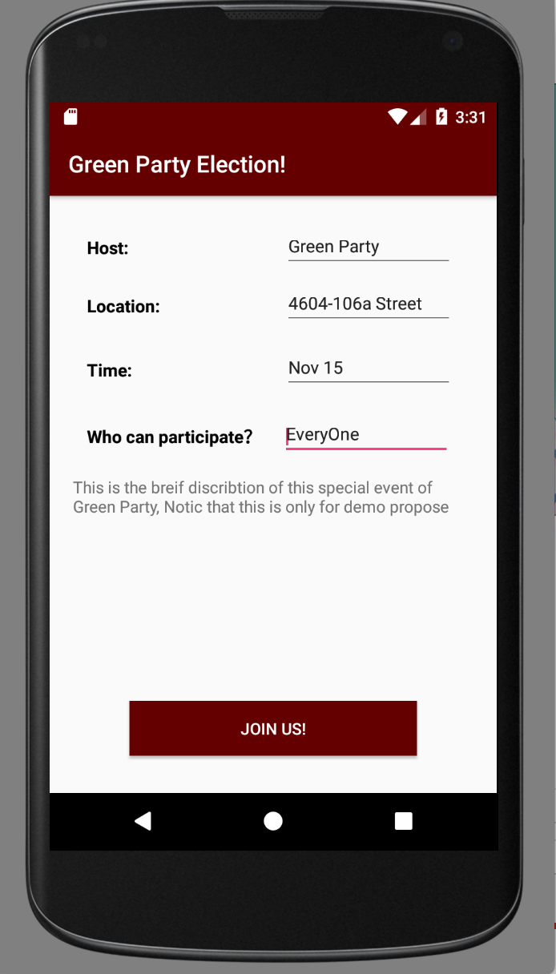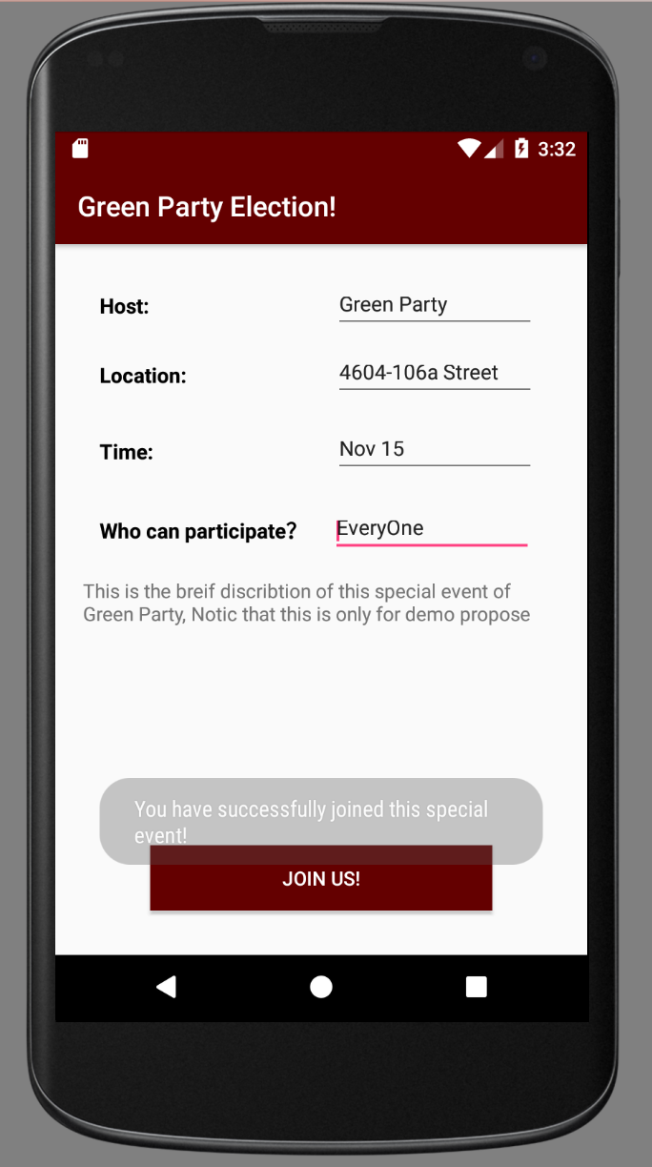

Figure 6.1 & 6.2

Figure 6 appears when user click the event text described in Figure 5.2. This page shows the detail information about the selected event (host name, event location, time and people who are eligible to participate), user may click the JOIN US button and the UI will pop up a message “You have successfully joined this special event!” ( Figure 6.2).

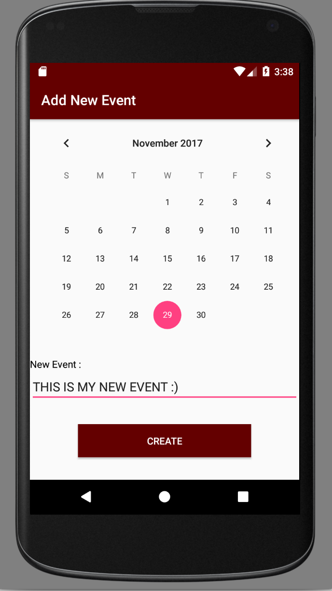

After User click the Add button from Figure 5.2, the app leads user to this page, user may able to add a custom event into the Calendar. After finish editing event detail, simply click Create Button and the user-defined event will be saved and displayed in the Calendar in Figure 5.2

Figure 7

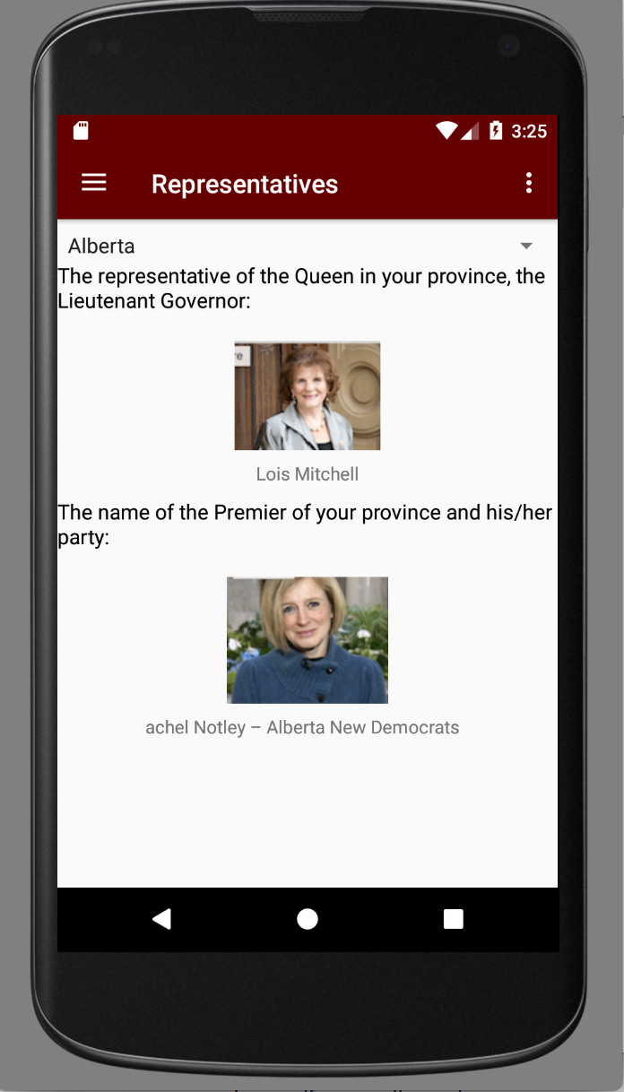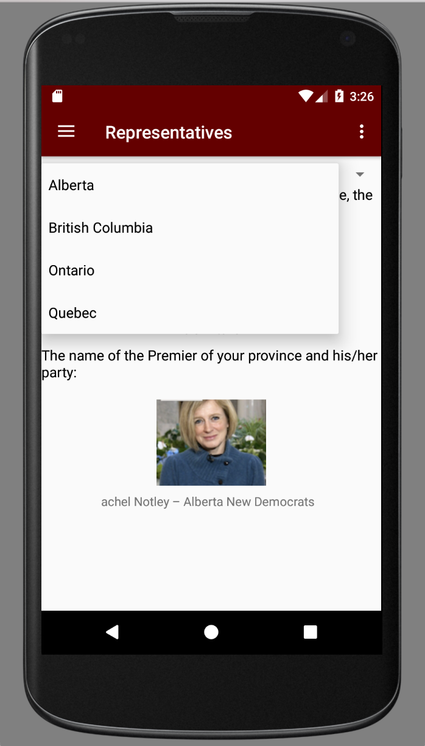

Figure 8

Figure 7 is the page after user clicked the “ Representatives “ button on the Menu page, it shows the current representatives in your province and the name of premier and his/her party. The images are clickable and there is a spinner on the top of the page, after clicked on the spinner, user may be able to select the province they want to view ( Figure 7.2 ) 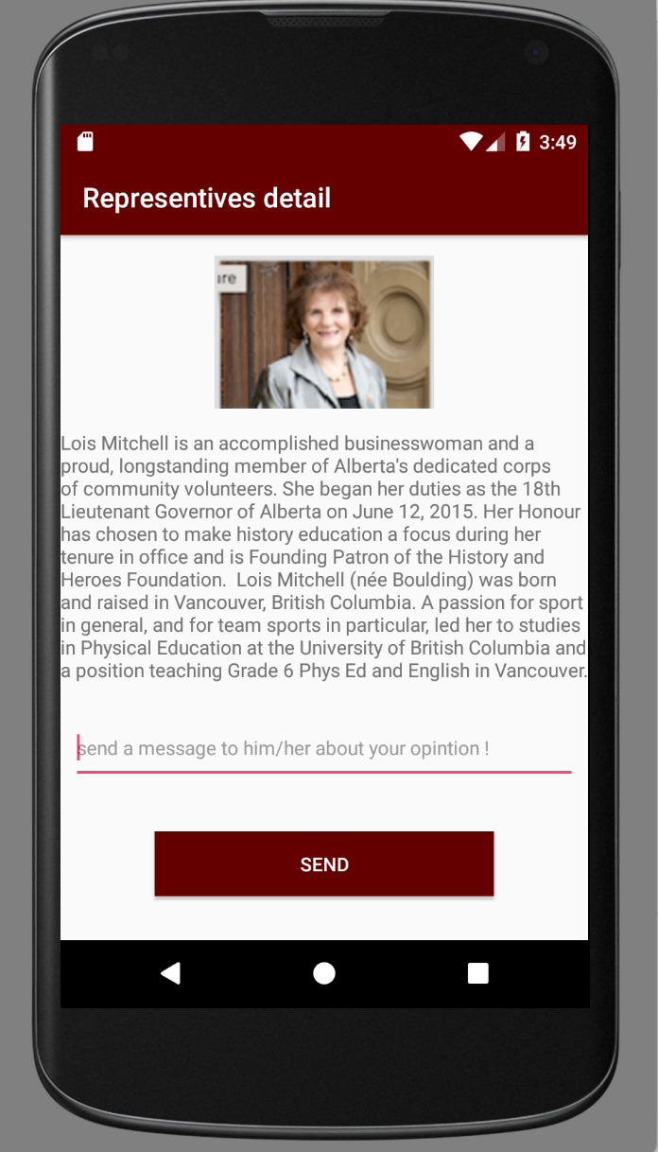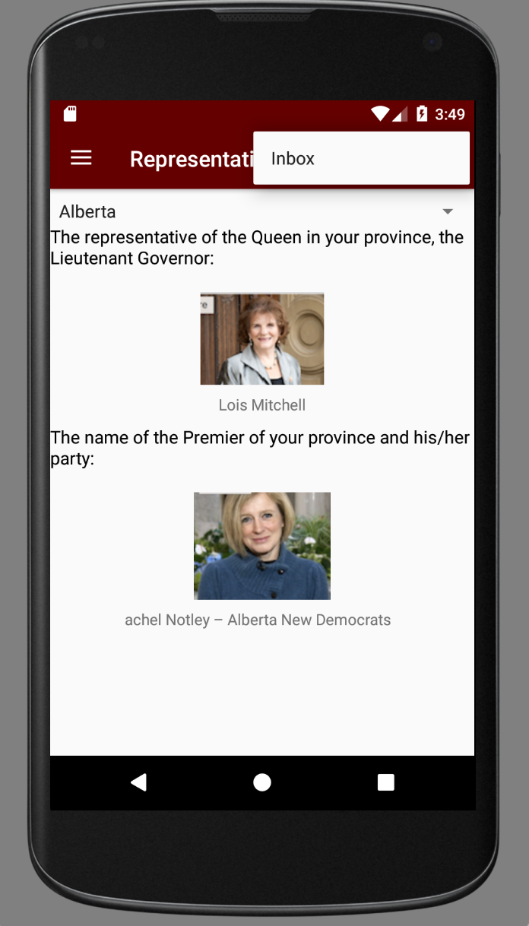

Figure 9.1 & 9.2

Figure 8.1 pops up when user click the image describe in Figure 7.1, it shows the detail information about the selected representative, user may able to send a message to this representative anonymity and they can get responses from the inbox on Figure 8.2 . The Inbox Button exists on every pages that have the Menu button.

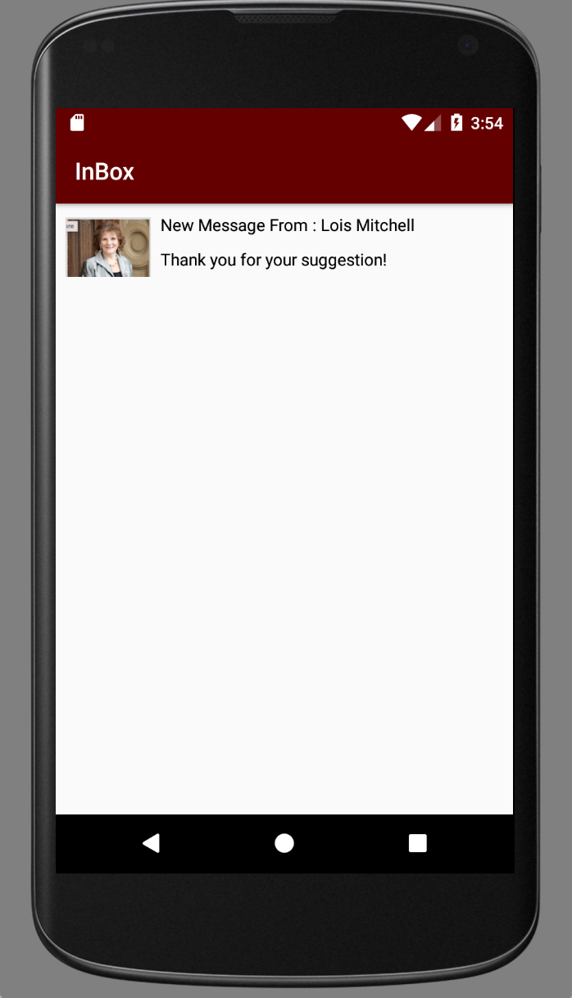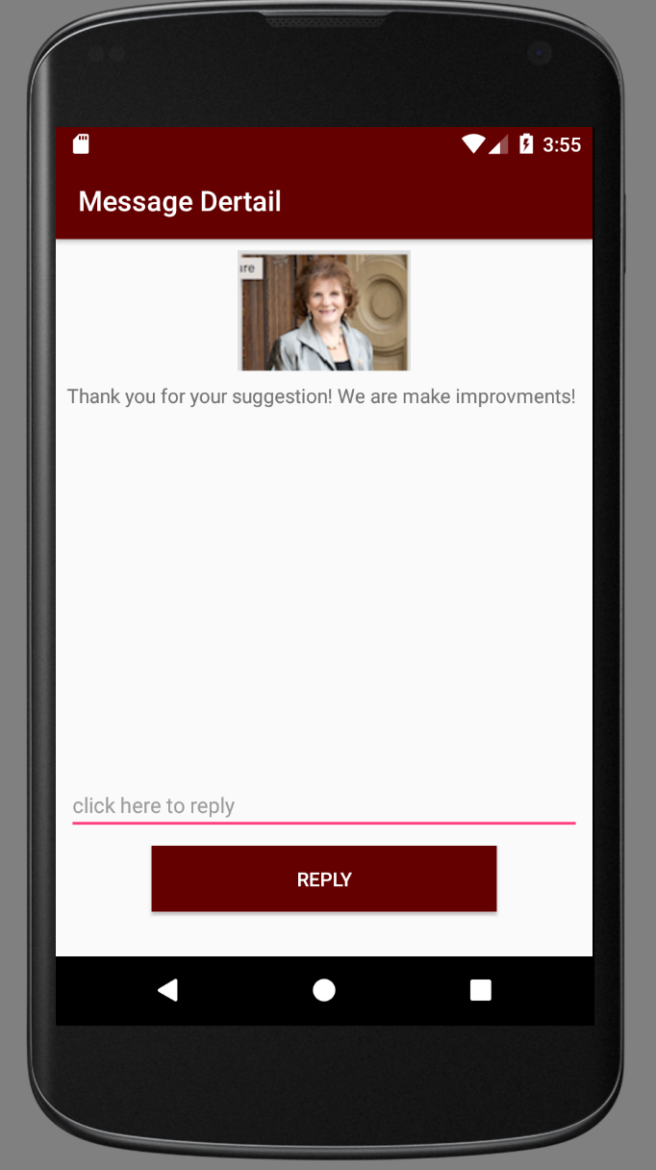

Figure 10.1 & 10.2

After user clicked the Inbox Button described in Figure 8.2, the app leads user to Figure 9.1 which shows a list of responses from the representatives, user may able to click the response text to view the detail (Figure 9.2 ) and keep communicate with him/her by entering the reply message and hit REPLY button.

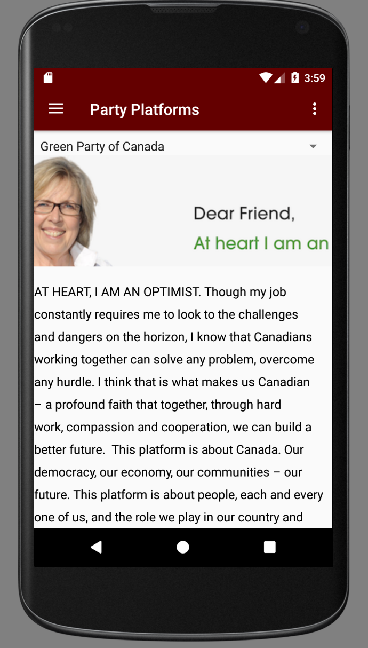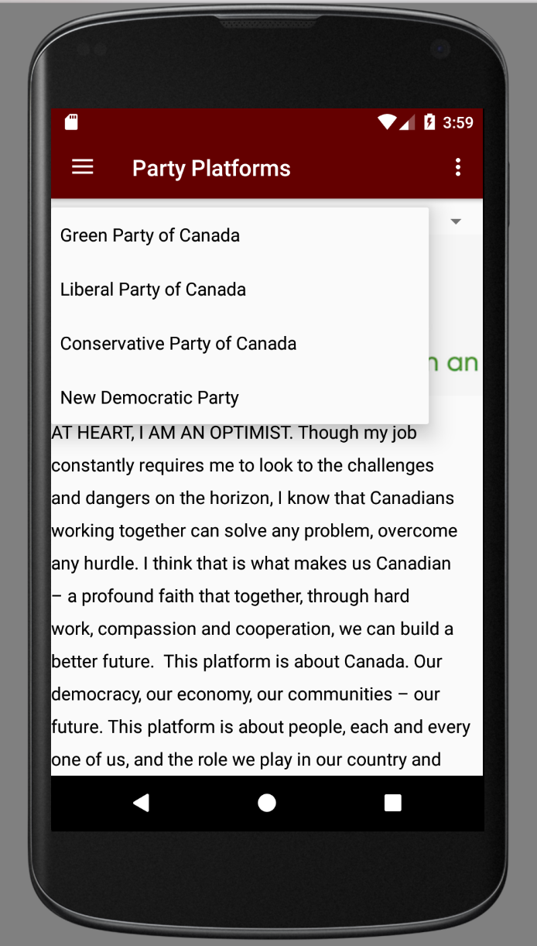

Figure 11.1 & 11.2

Figure 10 will be displayed after user clicked the Party Platform button on the Menu page. This page shows the detail information about the selected party, user may be able to select a party by clicking the spinner on the top of the screen (Figure 10.2).

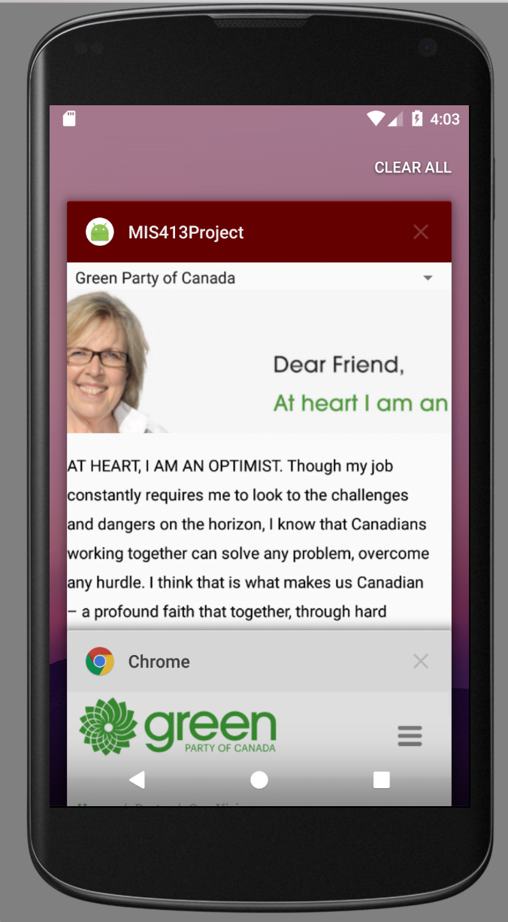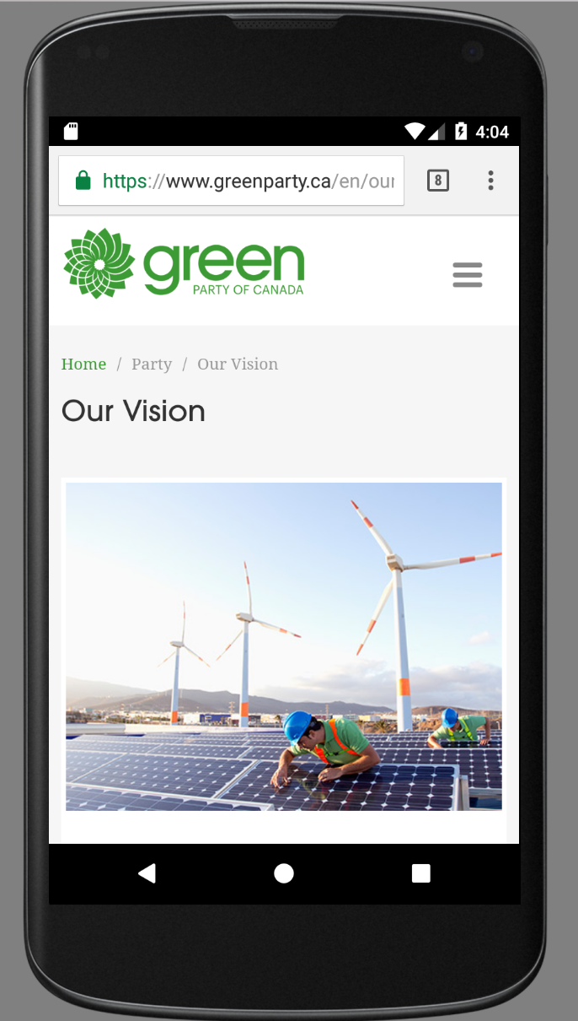

Figure 12.1 & 12.2

Again the Image is clickable which will leads user to its party website (Figure 11.1, Figure 11.2)

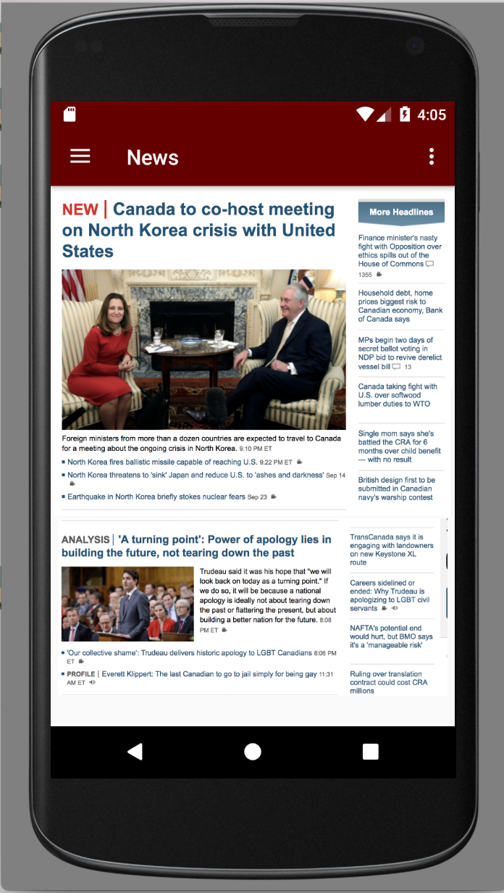

Figure 12 is displayed when user clicked “News” button on the Menu, this page shows the detail information about the political news, the links are clickable and will leads user to more detail page

Figure 13.1

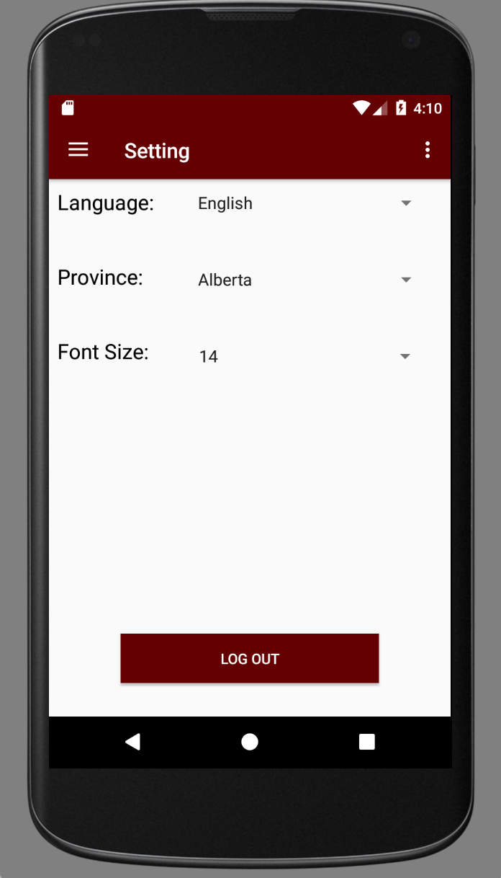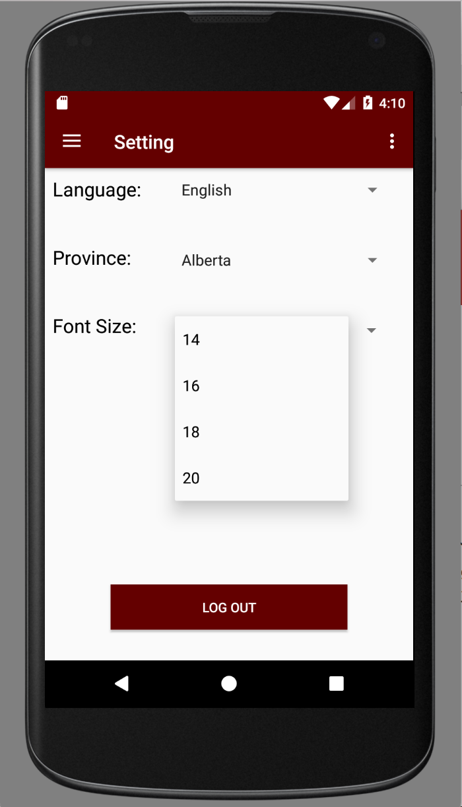

Figure 14.1 & 14.2

Figure 13 is displayed when user click the “Setting “ button on the Menu page, user may be able to switch between English and French , different Provinces and different font size by clicking the spinner on the right, at the end , user may click Logout button to actual logout the app.

## Class Model

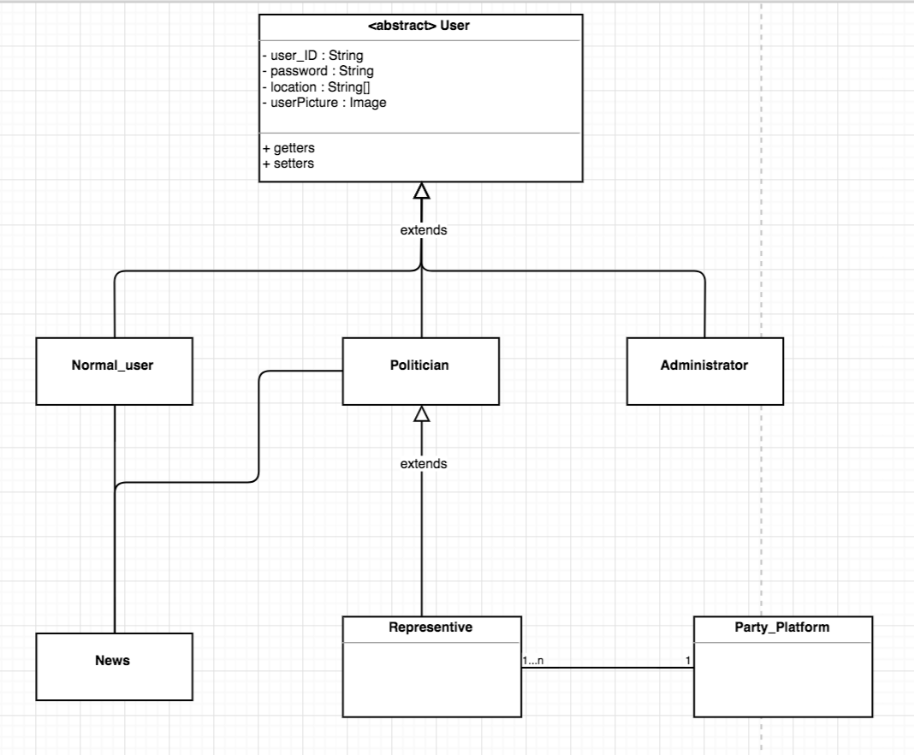

Figure 15: If you want to view the original Image, check the enclosed file named “Class Model.png”

## Physical Architecture Diagram

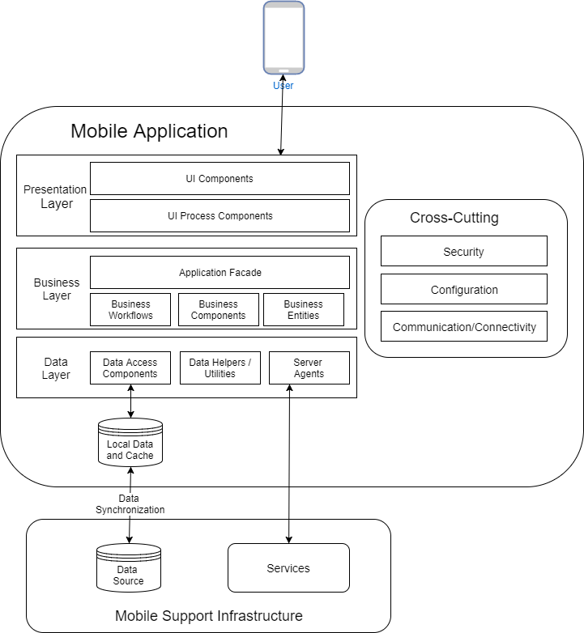

# Appendix A

## System Request Document

### Initial Project Scope

The government affects everyone, however not everyone even knows who their representatives are and what they stand for. The 18-24 age group in Canada have the lowest voter turnout at 58.8% in 2015 [10]. This same age group has the highest mobile app usage [11]. If voter information were available on a mobile application it would hopefully have a positive impact on voter turnout in this age group, as the information would be in a format that appeals to them. Our app would allow a user, either by using current location or entering a location, to see who their representatives are at the Municipal, Provincial, and Federal levels. The user could then click on their representative to see their official positions, their party affiliations, their contact info/social media, who their major sponsors are, and their voting history. The user could then click on the party affiliation to learn more about the official stances of their party. There would also be a calendar feature that shows all upcoming elections, town hall meetings, and any other type of official government forums. There would also be an option to see upcoming and past legislation at the Municipal, Provincial, and Federal levels. The user would be able to see the details of the legislation as well as the sponsors. There would be a simple keyword function as well as category sorting based on topic or most viewed when looking at legislation. Another feature could be current news related to Canadian politics which could be populated by Google News. The application would be required to be in both official languages of Canada so that all citizens can use it. This app would only require a database and some sort of middleware to transmit queries to the database and display the results in the application. This database could be populated using politician and voter info from Library and Archives Canada[12], Elections Canada Online [13], the OpenNorth database[14], as well as the official webpages of the representatives and official party websites. For this version of the application there would be no need for user login/signup. Future considerations of this project could involve adding a forum discussion on legislation, and perhaps even popular opinion polls, however these would require heavy moderation to be of any practical use and may not be covered in our current plan.

The planned features of this application so far are:

* List of user’s representatives at municipal, provincial, and federal levels based on location.
* Detailed information about representatives, including but not limited to party affiliation, campaign platforms, terms served, and voting history.
* Detailed description of party platforms taken from their party websites.
* Calendar feature with important upcoming dates such as elections.
* Current and past legislation at all levels of government.
* Detailed descriptions of the legislation.
* A search function for legislation based on keywords or topic searches.
* A news page for any articles about Canadian Politics.
* Both French and English language options.

### Schedule for Project

Team Member Responsibility & Time frame:

A: System Request Document (Daniel)

B: Term Project Review (Steven, Hamza, Daniel, Euinbin, Yongjia)

C: Problem Background Research (Daniel)

D: Executive Summary (Hamza)

E: System Proposal Document (Steven, Eunbin, & Yongjia)

F: Detailed Design Specification (Daniel, Euinbin & Yongjia)

### Gantt Chart:

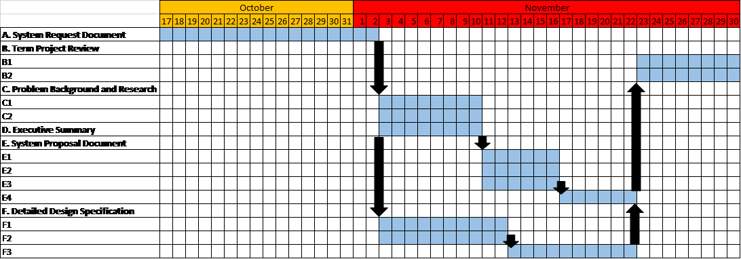

### Feasibility

This e-government app would be highly feasible as the technical side of things is quite straight forward. All we would need is a mobile application that connects and makes queries to a database. Populating this database will also be relatively simple as all the information required is open to the public. As the app doesn’t require user registration this means that the quality of the app experience will not be affected by how many people are currently using it. Since all the information is freely available the financial considerations of developing this app would simply be the cost of developers and the cost of hosting the database. The biggest obstacle to developing this application is that not all the information is currently in a database friendly format and may require significant manual input in the initial stages. A “go” decision for this application would certainly be a yes, as barring labour hours required to create it there are no significant legal or technological issues that would impede it.

# Appendix B

## References

1. Alvarez, R., Hall, T., and Treschel, A. (2009). Internet Voting in Comparative Perspective: The Case of Estonia. *PS: Political Science and Politics, Volume 42 Issue 3,* 497-505.
2. Blais, A., Gidengil, E., Fournier, P., and Nevitte, N. (2008) Information, visibility and elections: Why electoral outcomes differ when voters are better informed. *European journal of Political Research, Volume 48 Issue 2,* 256-280.
3. Dougherty, I. (2011, April 19). *The real reason why youth don’t vote.* Retrieved from http://www.canada.com/news/real+reason+youth+vote/4624373/story.html.
4. Esser, F. and de Vreese, C. (2007). Comparing Young Voters’ Political Engagement in the United States and Europe. *American Behavioral Scientist, 50,* 1195-1213.
5. Pasek, J., Kenski, K., Romer, D., and Jamieson, K. (2006). America’s Youth and Community Engagement: How Use of Mass Media Is Related to Civic Activity and Policitical Awareness in 14- to 22- Year Olds. *Communication Research, Volume 33 Issue 3,* 115-135.
6. Pruysers, S. (2013). Party Linkages in Federal States: An Examination of Elections and Parties in Ontario and Canada. Retrieved from <https://www.cpsa-acsp.ca/papers-2013/Pruysers.pdf>
7. contentshttps://www.lieutenantgovernor.ab.ca/about-the-lieutenant-governor/her-honour-the-honourable-lois-e-mitchell-cm-aoe-lld/
8. <http://www.ctvnews.ca/politics/u-s-officials-understand-buy-american-impact-rachel-notley-says-1.3310214>
9. <https://www.greenparty.ca/en/our-vision-new>
10. <http://www.cbc.ca/news/politics>
11. https://www.codementor.io/blog/how-much-does-it-cost-to-make-an-app-in-2017-1nqj6ehste
12. https://www.appsterhq.com/blog/app-development-cost/
13. https://www.payscale.com/research/CA/Skill=Data_Mining_%2F_Data_Warehouse/Salary
14. https://www.payscale.com/research/CA/Job=Business_Analyst%2C_IT/Salary
15. https://www.payscale.com/research/CA/Job=Mobile_Applications_Developer/Salary
16. https://www.payscale.com/research/CA/Job=Business_Analyst%2C_IT/Salary
17. https://www.payscale.com/research/CA/Job=Information_Systems_(IS)_Manager/Salary
18. <https://www.techrepublic.com/blog/software-engineer/app-store-fees-percentages-and-payouts-what-developers-need-to-know/>
19. http://www.elections.ca/content.aspx?section=res&dir=rec/eval/pes2015/vtsa&document=table1&lang=e
20. http://www.businessofapps.com/data/app-statistics/
21. http://www.bac-lac.gc.ca/eng/discover/politics-government/Pages/politics-government.aspx
22. http://www.elections.ca/content.aspx?section=ele&document=index&lang=e
23. https://represent.opennorth.ca/data/

1. http://www.elections.ca/content.aspx?section=res&dir=rec/eval/pes2015/vtsa&document=table1&lang=e
2. https://www.codementor.io/blog/how-much-does-it-cost-to-make-an-app-in-2017-1nqj6ehste
3. https://www.appsterhq.com/blog/app-development-cost/
4. https://www.payscale.com/research/CA/Skill=Data_Mining_%2F_Data_Warehouse/Salary
5. https://www.payscale.com/research/CA/Job=Business_Analyst%2C_IT/Salary
6. https://www.payscale.com/research/CA/Job=Mobile_Applications_Developer/Salary
7. https://www.payscale.com/research/CA/Job=Business_Analyst%2C_IT/Salary
8. https://www.payscale.com/research/CA/Job=Information_Systems_(IS)_Manager/Salary
9. https://www.techrepublic.com/blog/software-engineer/app-store-fees-percentages-and-payouts-what-developers-need-to-know/
10.
11.
12.
13.
14.